 4th Floor, Legacy Towers

Ministry of Education & Sports

Kyadondo Road, Nakasero

and, Suite 267 Serena Conference Centre

PO Box 11644

Kampala, Uganda

Uganda Police Force

Procurement and Disposal Unit,

P.O. Box 7055

Plot No. 66/68 Jinja Road, Estates Building

1st Floor Room 20

Kampala, Uganda

16th March 2020

**Attention: Head-PDU**

**RE: UPF/SUPLS/19-20/CFC 000038 (Lot 5)**

Masterlinks Uganda Limited is pleased to respond to a request for video enhancement software as detailed in the Standard Bid Document, with the reference above.

Masterlinks is the Ugandan representative of Kinesense Limited, a specialist supplier of video surveillance technologies, based in Dublin, the Republic of Ireland.

As Kinesense’s authorised representative in Uganda Masterlinks trusts that this response is in line with expectations and we are ready to clarify any matters, should these not be clear from our submission.

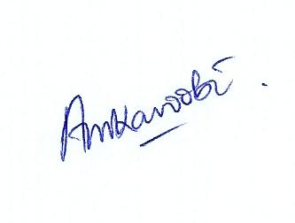Yours faithfully,



Alex Mukama

Director

Masterlinks Uganda Limited

PO Box 11644, Kampala

+256 780 566 688, +256 712 977 249

[masterlinksug@yahoo.com](mailto:masterlinksug@yahoo.com)

[www.masterlinksug.co.ug](http://www.masterlinksug.co.ug)

|  |
| --- |
| logo |
| **Procurement of video enhancement software:**  **UPF/SUPLS/19-20/CFC 000038** |
| **LOT 5** |

THIS RESPONSE SUBMITTED BY

MASTERLINKS UGANDA LTD.



# **Response fact sheet**

|  |  |
| --- | --- |
| **Programme Title:** | Procurement of video enhancement software  Procurement reference: UPF/SUPLS/19-20/CFC 00038 (Lot 5) |
| **Key Organisers:** | Republic of Uganda, Uganda Police Force  Masterlinks Uganda Limited  Kinesense Limited |
| **Masterlinks Company Data:** | Company registered in Uganda: 29th March 2006  URSB Registration number: 79370  Uganda Revenue Authority TIN: 1000108869 |
| **Document date and Validity:** | 16th March 2020, valid until and including 12/06/2020 |
| **Document Status:** | Approved for submission. |

***Copyright 2020 Masterlinks Group Ltd. All rights reserved.***

*Neither this document nor any part of it may be copied or reproduced without the prior written consent of the Masterlinks Group Ltd. The information contained in this document is subject to change or revision without prior notice.*

*This proposal is valid until* ***12th June 2020,*** *or later by agreement.*

*Masterlinks Group Ltd. will be bound only by those terms and conditions that are agreed to in a formal agreement and final contract signed by Masterlinks Group Ltd. and the client and not by the information or absence of information contained in this document.*

*The Masterlinks Group comprises Masterlinks Uganda Ltd., Masterlinks Community Services Ltd. and e-Learner Uganda Ltd.*

.**Masterlinks Contact Information**

Physical Addresses:

4th Floor, Legacy Towers Suite 267

Kyadondo Road, Serena Conference Centre

Nakasero, Kampala, Uganda Kampala, Uganda

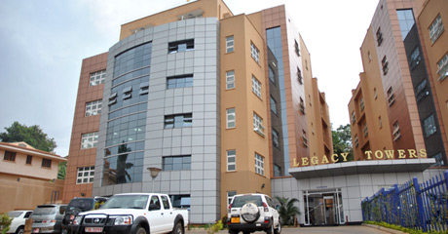

Postal Address: P. O. Box 11644, Kampala, Uganda

Contact Persons:

Alex Mukama Karoobi

+256 780 566 688 +256 712 977 249

[masterlinksug@yahoo.com](mailto:masterlinksug@yahoo.com)

Mike Watkins

+256 772 726 001

[Mikewatkins001@gmail.com](mailto:Mikewatkins001@gmail.com)

[www.masterlinks.co.ug](http://www.masterlinks.co.ug)

**Kinesense Contact Information**

Contact Person:

Ms Sarah Doyle

Physical Address: 79 Merrion Square

Dublin 2, Ireland

+353 166 24546

[info@kinesense-vca.com](mailto:info@kinesense-vca.com)

[www.kinesense-vca.com](http://www.kinesense-vca.com)

Table of Contents

**i.** **Response fact sheet** 3

**Executive Summary - Lot 5: Video enhancement software** 6

**Masterlinks’ response to Standard Bidding Document for the Procurement of Supplies.** 8

(a) The Bid Submission Sheet 8

(b) a Bid Security or a Bid Securing Declaration 8

(c) Written confirmation authorising the signatory of the bid to commit the Bidder 10

(d) Documentary evidence in accordance with ITB Clause 16 establishing the Bidder’s eligibility to bid; 12

(e) documentary evidence establishing that the Supplies and Related Services to be supplied by the Bidder are of eligible origin; 16

(f) Documentary evidence that the Supplies and Related Services conform to the Bidding Documents; 17

(g) documentary evidence establishing the Bidder’s qualifications to perform the contract if its bid is accepted; 18

(h) The Code of Ethical Conduct for Bidders 18

(i) any other document(s) required in the BDS. 20

Section 5: Eligible Countries 24

2. Delivery and Completion Schedule 25

3. Specification and Compliance Sheet 26

# **Executive Summary - Lot 5: Video enhancement software**

Kinesense Limited is a specialist developer of video analytics software designed for police and security services. The company is based in Dublin, Republic of Ireland, with offices in the USA and the UK.

The Kinesense system proposed here is a complete package and can be installed and be operational in one day. The software can analyse video data from virtually all known video formats and, as new formats are developed, the software will be amended to handle that data.

The system is designed to be installed with a small, affordable footprint, which can be easily upgraded with more users and with additional functionality. The software proposed here is the recommended system for law enforcement agencies (LE), with other specialist versions available for national defence forces, private security organisations and retail environments. As the needs of the UPF change and increase so the system can be enhanced with more sophisticated modules of software. This approach is recommended to the UPF as from experience of working with more than 100 police and security forces, organisations can take time to develop their skills and capabilities, and many will never need any of the additional modules.

The software can be installed and operated as either stand-alone (installed on individual PCs) or in a client / server networked configuration.

Optional modules include a Face Detection & Attribute module: This solution can analyse video to find all faces in the video, which can:

• Filter faces by age

• Filter faces by gender

• Filter faces by wearing glasses/no glasses.

Also, an Automatic number-plate recognition (ANPR) Processing system will be available as a separately licensed product by the end of 2020. This will analyse video to detect licence plates, and extract image of licence plates and OCR number to a file.

The Law Enforcement version of software is currently installed at more than 100 police forces and national security organisations, while there are many clients that must remain confidential the following have authorised for publication their use of Kinesense systems:

United Kingdom (over 25 forces), including:

·         London Metropolitan Police

·         Northumbria Police Force

·         Greater Manchester Police

·         Cleveland Police

·         Devon & Cornwall Police

·         Surrey & Sussex Police

·         HM Revenue & Customs

·         Northamptonshire Police

·         West Yorkshire Police

Europe (over 40 customers) including:

·         Belgium Police (multiple customers)

·         Netherlands Police

 India (over 20 customers), including:

·         Maharashtra State Cyber Crime

·         Chennai police

Rest of the World (over 30 customers)

·         Nepali Police

·         Indonesian National Intelligence Agency

·         Moroccan Police

·         Ministry of Interior, South Korea

·         Italian SCO

·         Czech Republic Police

·         Cyprus National Police.

Kinesense Limited is represented in Uganda by Masterlinks Uganda Limited, a consulting and training company, registered by shares, in May 2006. Masterlinks has three registered directors, two of whom are Ugandan and one is British.

Masterlinks assignments have recently been completed or are ongoing for; The Ministry of Defence and Veterans Affairs, Office of the Prime Minister, CNOOC Uganda Limited and Total Uganda Limited, among others.

# **Masterlinks’ response to Standard Bidding Document for the Procurement of Supplies.**

**Procurement of Video enhancement software. Procurement Ref Number:** **UPF/SUPLS/19-20/CFC 00038 (Lot 5)**

*11. Documents Comprising the Bid*

### (a) The Bid Submission Sheet

*The Bid Submission Sheet is attached as a separate document together with the Pricing Schedule*

### (b) a Bid Security or a Bid Securing Declaration

 4th Floor, Legacy Towers

Kyadondo Road, Nakasero

and, Suite 267 Serena Conference Centre

PO Box 11644

Kampala, Uganda

**Bid-Securing Declaration**

Date: *16th March 2020*

Subject of procurement and Reference No.: ***UPF/SUPLS/19-20/CFC/00038***

To: **Uganda Police Force**

We, the undersigned, declare that:

1. We understand that, according to your conditions, bids must be supported by a Bid- Securing Declaration.

2. We accept that we will automatically be suspended for three years by the Authority from being eligible for bidding in any contract with the Government of Uganda*,* if we are in breach of our obligation(s) under the bid conditions, because we:

(a) have withdrawn our bid during the period of bid validity specified by us in the Bid Submission Sheet or

(b) having been notified of the acceptance of our bid by the Procuring and Disposing Entity during the period of bid validity fail or refuse to (i) sign the contract, (ii) fail or refuse to furnish the Performance Security in accordance with ITB Clause 43; or (iii) fail or refuse to accept the correction of our bid by the Procuring and Disposing Entity, pursuant to ITB Clause 31;

3. We understand this Bid Securing Declaration shall cease to be valid if I/we are not the successful Bidder, upon the earlier of (i) the expiry of the notice of best evaluated bidder or (ii) upon the expiration of the validity of my/our bid on the ***12/06/2020***,

Signed:

In the capacity of *Director*

Name: *ALEX MUKAMA KAROOBI*

Duly authorized to sign the bid securing declaration for and on behalf of: *Masterlinks Uganda Limited*

Dated on: *16th day of March 2020*

### (c) Written confirmation authorising the signatory of the bid to commit the Bidder

*Confirmed*

*A letter certifying Masterlinks’ ability to represent Kinesense limited, a sub-contractor and provider of the software in Uganda’, is provided below:*

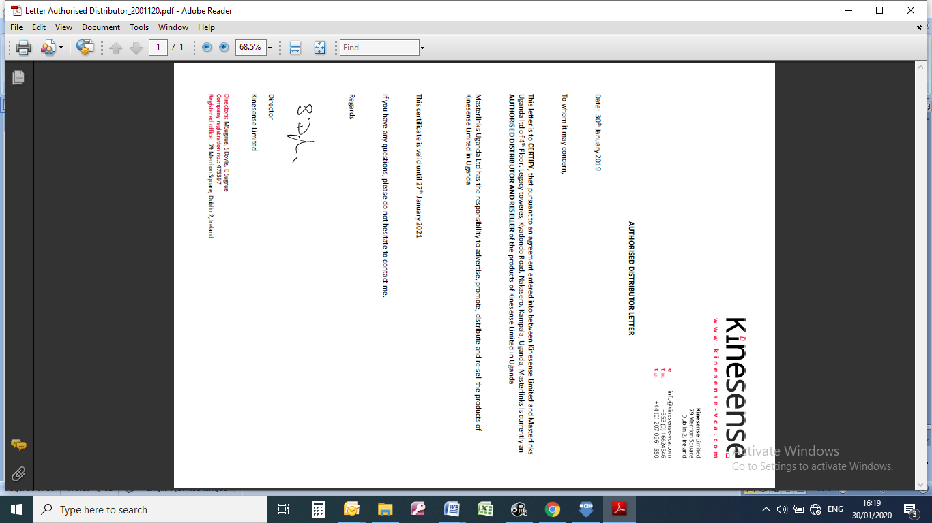

### (d) Documentary evidence in accordance with ITB Clause 16 establishing the Bidder’s eligibility to bid;

***Eligibility sections of the Bid Submission Sheet have been completed in accordance with ITB Clause 16***

*The following documentation required to provide evidence of eligibility is attached below:-*

*(a) a certificate of registration issued by the Authority for bidders currently registered with the Authority or a copy of the Bidder’s Trading licence or equivalent and a copy of the Bidder’s Certificate of Registration or equivalent for bidders not currently registered with the Authority;*

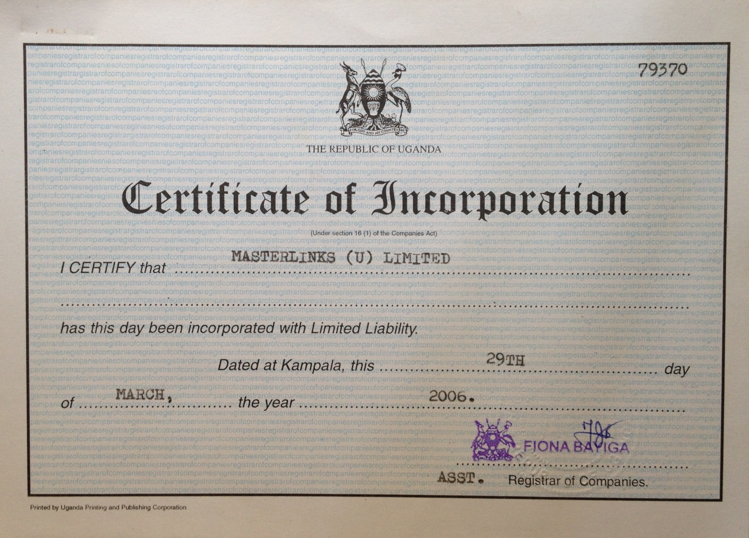**CERTIFICATE OF INCORPORATION**

**KCCA TRADE LICENCE CERTIFICATE**

(b) a statement in the Bid Submission Sheet that the bidder meets the eligibility criteria stated in ITB 4.1;

*Eligibility sections of the Bid Submission Sheet have been completed in accordance with ITB 4.1*

(c) a declaration in the Bid Submission Sheet of nationality of the Bidder;

*Declarations of the nationality of the bidder in the Bid Submission Sheet are provided*

(d) a declaration in the Bid Submission Sheet that the Bidder is not under suspension by the Authority;

*A declaration that the Bidder is not under suspension by the Authority has been stated in the Bid Submission Sheet*

(e) Fulfilment of obligations to pay taxes and social security contributions in Uganda where applicable

*A tax clearance certificate and Registration certificate with NSSF are attached below.*

**TAX CLEARANCE CERTIFICATE**

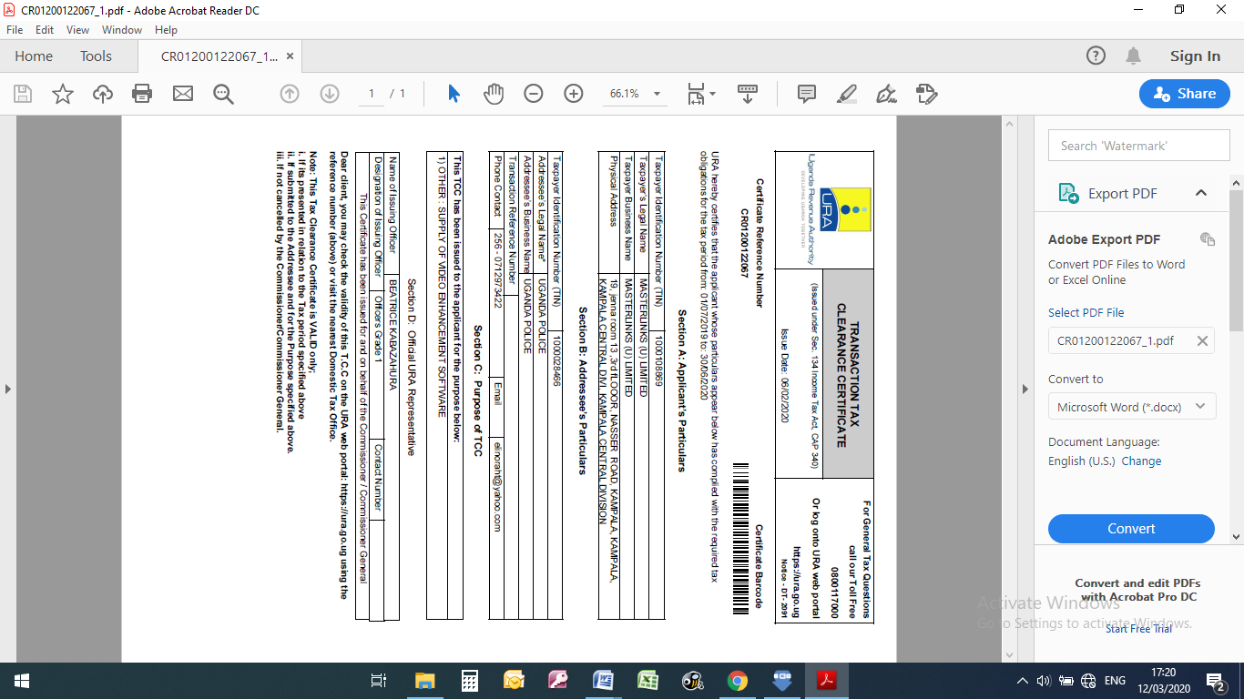

**NSSF REGISTRATION CERTIFICATE**

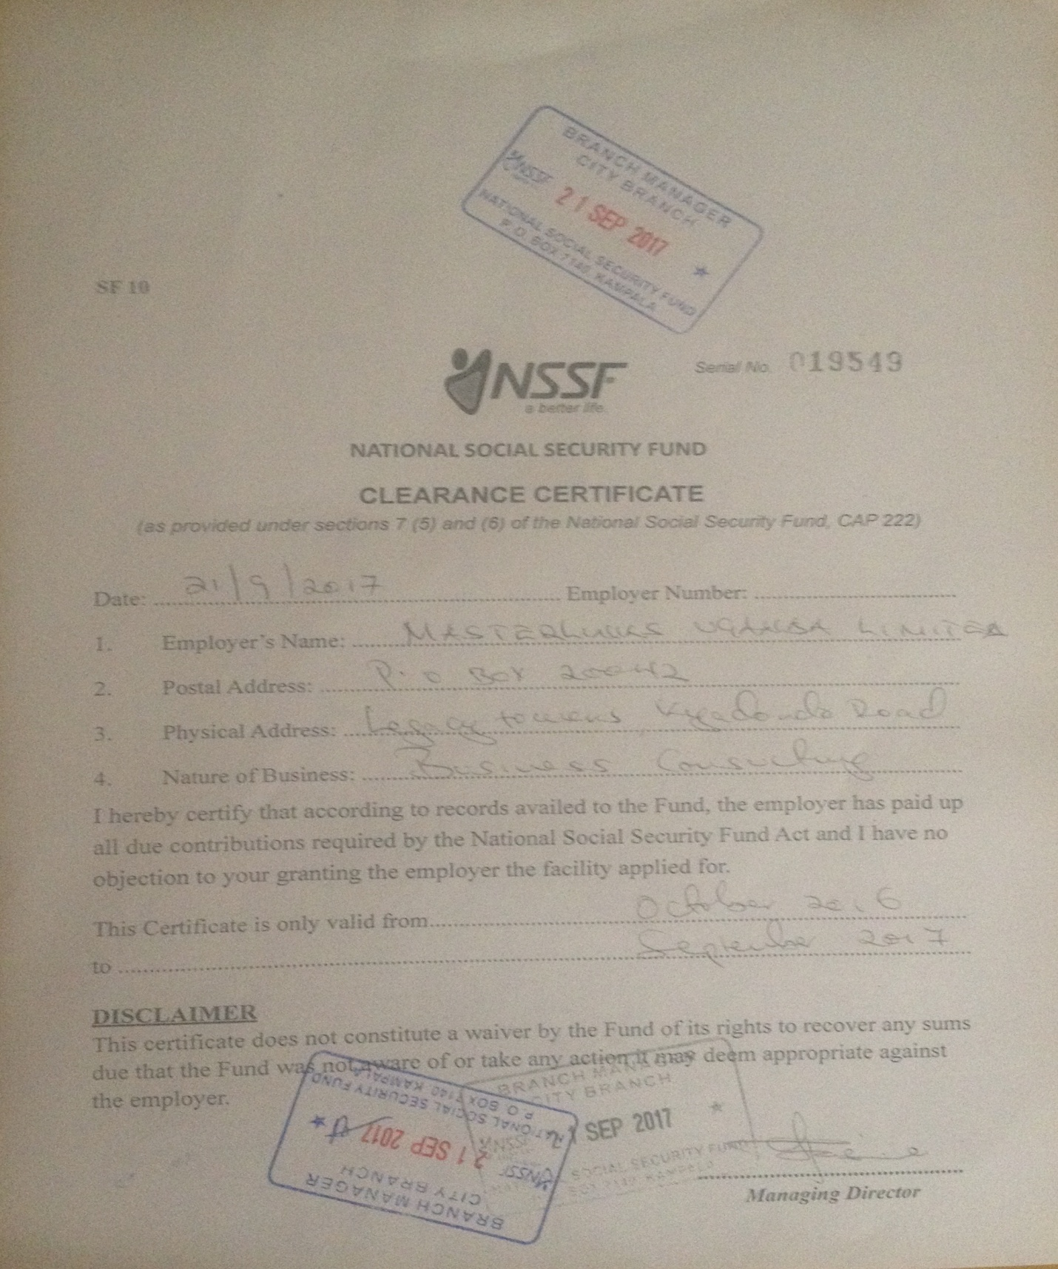

### (e) documentary evidence establishing that the Supplies and Related Services to be supplied by the Bidder are of eligible origin;

17.1 To establish the eligibility of the Supplies and Related Services, in accordance with ITB Clause 5, Bidders shall complete the country of origin declarations in the Price Schedule included in Section 4, Bidding Forms.

*This information is provided in the Price Schedule, under separate cover*

17.2 Bidders with a current registration with the Authority are not required to submit:

(a) a copy of the bidder’s current trading licence or equivalent;

*Attached below*

(b) a copy of the bidder’s certificate of registration or equivalent;

*Attached below*

### (f) Documentary evidence that the Supplies and Related Services conform to the Bidding Documents;

|  |
| --- |
| 18.1 To establish the conformity of the Supplies and Related Services to the Bidding Documents, the Bidder shall provide as part of its bid the documentary evidence specified in Section 6, Statement of Requirements.  *This information is provided in Section 6: Statement of Requirements*  18.2 The documentary evidence may be in the form of literature, drawings or data, and shall consist of a detailed description of the essential technical and performance characteristics of the Supplies and Related Services, demonstrating substantial responsiveness of the Supplies and Related Services to those requirements, and if applicable, a statement of deviations and exceptions to the provisions of the Statement of Requirements.  *This information is provided in Appendix 1 and 2, below: Kinesense Extended Profile and Case Studies* |
| 18.3 If so stated in the BDS bidders may be required to submit representative samples of the Supplies being offered and/or be requested to demonstrate the operation of the supplies to the PDE.  *A demonstration of the software can be arranged, if required* |
| 18.4 Standards for workmanship, process, material, and equipment, as well as references to brand names or catalogue numbers specified by the PDE in the Statement of Requirement, are intended to be descriptive only and not restrictive. The Bidder may offer other standards of quality, brand names, and/or catalogue numbers, provided that it demonstrates, to the PDE’s satisfaction, that the substitutions ensure substantial equivalence or are superior to those specified in the Statement of Requirement.  *Noted* |

### (g) documentary evidence establishing the Bidder’s qualifications to perform the contract if its bid is accepted;

To establish its qualifications to perform the Contract, the Bidder shall submit the evidence indicated for each qualification criteria specified in Section 3, Evaluation Methodology and Criteria.

*Noted. The requested information is attached.*

### (h) The Code of Ethical Conduct for Bidders

3.4 In pursuit of the policy defined in Sub-clause 3.1, the Government of Uganda requires representatives of both the PDEs and of Bidders and Providers to adhere to the relevant codes of ethical conduct. The Code of Ethical Conduct for Bidders and Providers as provided in the bidding forms shall be signed by the Bidder and submitted together with the other bidding forms.

*The Code of Ethical Conduct form is signed by Masterlinks and is attached below.*

**CODE OF ETHICAL CONDUCT IN BUSINESS FOR BIDDERS AND PROVIDERS**

(Under Section 93 of the Public Procurement and Disposal of Public Assets Act, 2003)

1. **Ethical Principles**

Bidders and providers shall at all times-

1. maintain integrity and independence in their professional judgement and conduct;
2. comply with both the letter and the spirit of-
3. the laws of Uganda; and
4. any contract awarded.
5. avoid associations with businesses and organisations which are in conflict with this code.
6. **Standards**

Bidders and providers shall-

1. strive to provide works, services and supplies of high quality and accept full responsibility for all works, services or supplies provided;
2. comply with the professional standards of their industry or of any professional body of which they are members.
3. **Conflict of Interest**

Bidders and providers shall not accept contracts which would constitute a conflict of interest with, any prior or current contract with any procuring and disposing entity. Bidders and providers shall disclose to all concerned parties those conflicts of interest that cannot reasonably be avoided or escaped.

1. **Confidentiality and Accuracy of Information**

(1) Information given by bidders and providers in the course of procurement processes or the performance of contracts shall be true, fair and not designed to mislead.

(2) Providers shall respect the confidentiality of information received in the course of performance of a contract and shall not use such information for personal gain.

1. **Gifts and Hospitality**

Bidders and providers shall not offer gifts or hospitality directly or indirectly, to staff of a procuring and disposing entity that might be viewed by others as having an influence on a government procurement decision.

1. **Inducements**

(1) Bidders and providers shall not offer or give anything of value to influence the action of a public official in the procurement process or in contract execution.

(2) Bidders and providers shall not ask a public official to do anything which is inconsistent with the Act, Regulations, Guidelines or the Code of Ethical Conduct in Business.

1. **Fraudulent Practices**

Bidders and providers shall not-

1. collude with other businesses and organisations with the intention of depriving a procuring and disposing entity of the benefits of free and open competition;
2. enter into business arrangements that might prevent the effective operation of fair competition;
3. engage in deceptive financial practices, such as bribery, double billing or other improper financial practices;
4. misrepresent facts in order to influence a procurement process or the execution of a contract to the detriment of the Procuring and Disposing Entity; or utter false documents;
5. unlawfully obtain information relating to a procurement process in order to influence the process or execution of a contract to the detriment of the PDE; and
6. withholding information from the PDE during contract execution to the detriment of the PDE.

I *ALEX MUKAMA KAROOBI* agree to comply with the above code of ethical conduct in business.





**AUTHORISED SIGNATORY**

**NAME OF BIDDER/PROVIDER:** *MASTERLINKS UGANDA LIMITED*

### (i) any other document(s) required in the BDS.

*The following additional documents are attached below:*

*- Powers of Attorney*

*- PPDA Registration certificate*

**POWERS OF ATTORNEY**





**PPDA REGISTRATION CERTIFICATE**



## Section 5: Eligible Countries

**Procurement Reference Number: UPF/SUPLS/19-20/CFC 000038 (Lot 5)**

All countries are eligible except countries subject to the following provisions.

A country shall not be eligible if:

(a) as a matter of law or official regulation, the Government of Uganda prohibits commercial relations with that country, provided that the Government of Uganda is satisfied that such exclusion does not preclude effective competition for the provision of supplies or related services required; or

(b) by an act of compliance with a decision of the United Nations Security Council taken under Chapter VII of the Charter of the United Nations, the Government of Uganda prohibits any import of Supplies from that country or any payments to persons or entities in that country.

***NOTED:*** *countries associated with this bid are:*

* *The Republic of Uganda,*
* *The Republic of Ireland,*
* *The United Kingdom of Great Britain & Northern Ireland.*

## 2. Delivery and Completion Schedule

**Procurement Reference Number: UPF/SUPLS/19-20/ 00038**

The delivery or completion period shall commence from the date of contract signature and effectiveness. Refer to the Incoterm in the GCC26 for the interpretation of the delivery period.

| **Item number** | **Brief Description of Supplies or Related Services** | **Delivery/ Completion Period**  *(days/wks/mths)* | **Delivery Point/ Site** |
| --- | --- | --- | --- |
| 1 | As specified in part 3 | Delivered within **03** weeks from the date of purchase order | DAP (Police ICT Stores Naguru) |

***NOTED****: delivery of software can be completed within the specified time, by arrangement with stakeholders in the UPF.*

## 3. Specification and Compliance Sheet

**Procurement Reference Number: UPF/SUPLS/19-20/ 00038**

Column b states the minimum technical specification of the item(s) required by the Procuring and Disposing Entity.

The Bidder is to complete column c with the technical specification of the item(s) offered and to state “comply” or “not comply” and give details of the areas of non-compliance.

Column d provides the technical literature of the specification offered.

*A completed form is attached below:*

**Part 2: Statement of Requirements**

**Specification and Compliance Sheet**

Procurement Reference Number: **UPF/SUPLS/19-20/CFC 00038 (Lot 5)**

Purchase Order Serial Number: ______________________________

*[Purchase Order Serial Number to be completed in the event of award of contract only]*

*Complete column c with the specification of the supplies offered. Also state “comply” or “not comply” and give details of any non-compliances to the specification required. Attach detailed technical literature if required. Authorise the specification offered in the signature block below.*

| **Item No** | **Technical Specification Required** | **Compliance of Specification Offered** | **Technical literature on specification offered in column c** |
| --- | --- | --- | --- |
| ***a*** | ***B*** | ***c*** | ***d*** |
| 01 | **Programming Software and license**  **(Video enhancement and investigation software** **for three users with three years license)** | **Comply** | **The software is offered with an open / perpetual licence, for a single machine with unlimited users** |
|  | * Should enhance images and videos from any source including body cameras, mobile phones and Social media platforms | Comply | The software works with all current video formats, including data from body cameras, and many legacy formats. The software is updated as new formats appear on the market. |
|  | * Identify important details like faces, Number plates | Comply | Face identity and number plate recognition are included in the standard product, which is specified here.  Note that additional and separate modules are available, at extra cost, which include:  Face Detection & Attribution, which analyses video to find all faces in the video. These faces can then be filtered by:  • Filter faces by age  • Filter faces by gender  • Filter faces by wearing glasses/no glasses.  Also, an Automatic number-plate recognition (ANPR) Processing system will be available as a separately licensed product by end-2020 This will analyse video to detect licence plates, extract image of licence plate and OCR number to a file. |
|  | * Export files for court in any required format | Comply | Data is exported in a format specified by court authorities in each jurisdiction, for presentation to judiciary, using a storyboard approach. This is a standard feature used by clients around the world. Kinesense is the only known solution to provide all reporting tools in one platform conforming to the ISO 17025 international standard. |
|  | * Conduct a proficiency Test to assure quality of image/Video | Comply | As the software handles multiple video formats it automatically carries out tests to evaluate the quality of recorded video data. |
|  | * Capable to restore, clarify, and analyze images and video in a simple, fast, and precise way. | Comply | The main function of the software is to enhance the images captured from CCTV and other sources, and is easy and quick to locate footage of interest and provide court-ready documents. |
|  | * Designed based on investigative, forensic, military and security application need. | Comply | Kinesense software is designed and produced by international investigative experts, specifically for use by police and security services worldwide |
|  | * Maintain the original evidence integrity. | Comply | The integrity of the original evidence is maintained at all times. All enhancement operations take place using data extracted from the original source. |
|  | * The video enhancement software should be open licensed or perpetual | Comply | The software is licensed on an open / perpetual basis |

**Specification and Compliance Sheet Authorised By:**

|  |  |  |  |
| --- | --- | --- | --- |
| Signature: | Alex signature.jpg | Name: | **Alex Mukama Karoobi** |
| Position: **Director** |  | Date: | **16/03/2020** |
| Authorised for and on behalf of: | |  | *(DD/MM/YY)* |
| Company: | **Masterlinks Uganda Limited** | | |

The detailed technical evaluation will examine the technical specification of the items offered in column c and determine whether this meets the minimum specification in column b. Bidders must complete column c or the bid will be rejected. **Bidders are required to use column d to include technical literature to support the details provided in column c.**

*Noted.*